Community Engagement

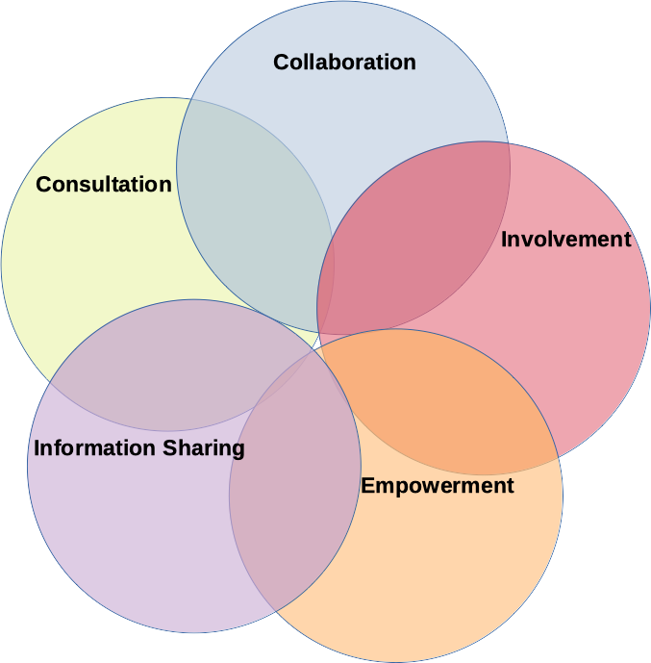
Click inside the text boxes in the diagram to add descriptors for each of the elements of community engagement. There are no right answers. Draw on what you have learned from the CRSJ counselling model, your Internet search of community engagement models, and your own experience working with, and living in, in community.

